Department of Computer Science and Engineering (Data Science)
CSDS-A | Batch A3 (CSE - Data Science, Section A)
A Dynamic Phishing URL Detection System Integrating Advanced Machine Learning and Crowdsourced Threat Intelligence
(PhishGuard)
S.No. | Student name | Roll / hall ticket no.
1 | D.ANISH MEGHAN | 23K91A6750
2 | B.AKSHAYA | 23K91A6737
3 | B.TANUJA | 23K91A6736
4 | CH.SAI CHETHAN | 23K91A6742
Under the guidance of: Mr. G. Ravi, [DESIGNATION]
DESIGN AND IMPLEMENTATION
This document describes the design of PhishGuard and how it was implemented: the architecture, the modules, the database schema, the API, key code walkthroughs, and the reasoning behind the main implementation decisions.

1 System Architecture
PhishGuard is a three-tier local application: a React interface, a Flask API with the detection modules, and local storage. The detection modules are ordinary Python code, so the same pipeline is reachable from the web interface, the original Flask pages and the command line.
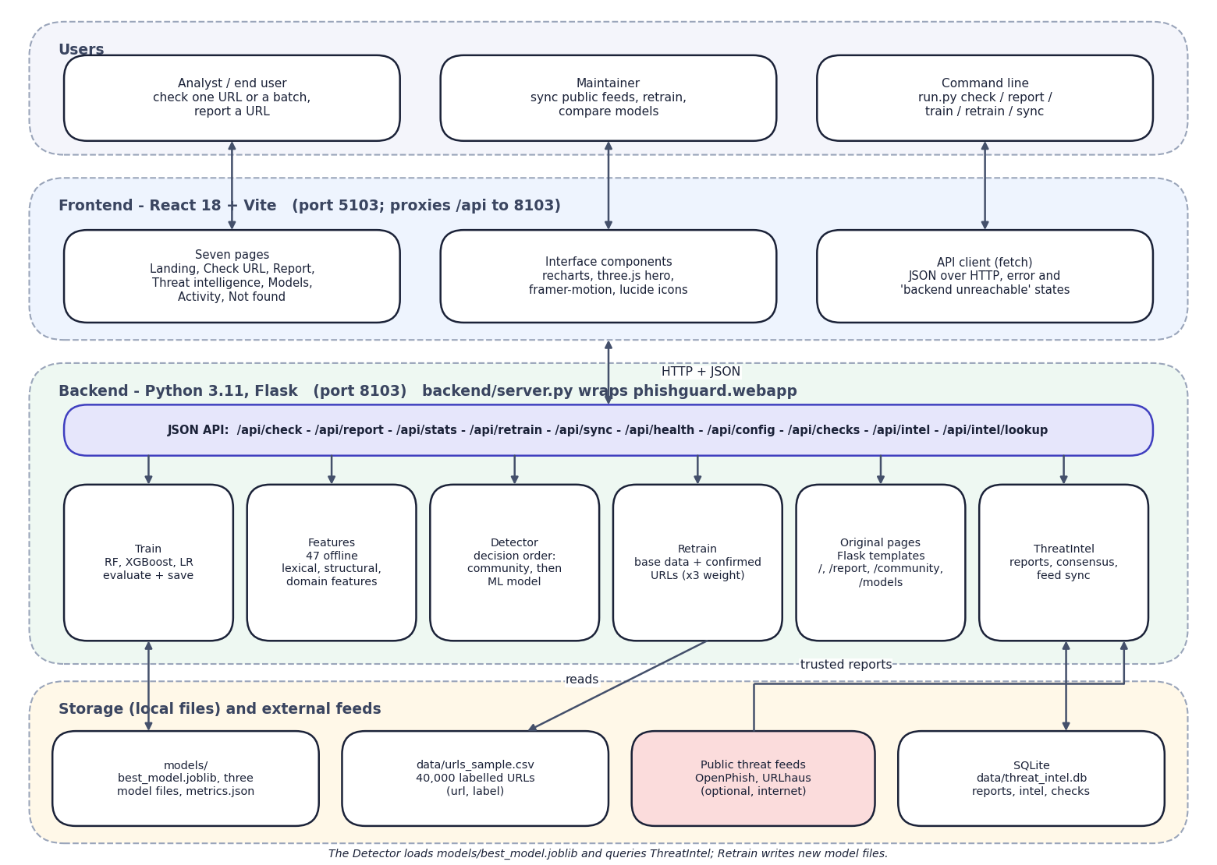
Fig. 1: System architecture of PhishGuard
The architecture has four layers. Users reach the system through the React interface on port 5103 or the command line. The Vite dev server serves the seven pages and proxies every /api call to the Flask application on port 8103, so the browser talks to one origin. backend/server.py wraps the original Flask application (phishguard.webapp) without changing it and adds five read-only JSON endpoints and the CORS header.
Behind the API are six modules. Features turns a URL into 47 numbers; Detector applies the decision order; ThreatIntel stores reports and computes consensus; Train fits and compares the models; Retrain merges confirmed URLs into the training data; and the original pages module keeps the first Flask interface alive. Storage is local: the SQLite file threat_intel.db, the model files and metrics.json, and the dataset CSV. The two public feeds are the only external systems, and they are optional.

2 Module Design
Table 1: Module breakdown
Module | File | Responsibility | Main functions
Features | phishguard/features.py | URL normalisation, 47 features, red flags | normalize_url, extract_features, featurize_urls, explain_features
Data | phishguard/data.py | Load, clean and split the dataset | load_dataset, build_matrices, dataset_summary
Train | phishguard/train.py | Fit, evaluate and save three models; metrics.json | build_models, evaluate, train_all, load_metrics
ThreatIntel | phishguard/threat_intel.py | Reports, votes, consensus, feed sync, check log | report, lookup, lookup_host, sync_feeds, stats
Detector | phishguard/detector.py | Decision order and hot reload | check, ml_probability, reload
Retrain | phishguard/retrain.py | Merge confirmed URLs and retrain | retrain, maybe_auto_retrain
Web app | phishguard/webapp.py | Original Flask pages and the JSON API | create_app
API layer | backend/server.py | Adds five read-only endpoints and CORS; port 8103 | build_app
CLI | run.py | train, check, report, sync, retrain, serve, download | cmd_*
Frontend | frontend/src | Seven pages, components, API client | pages/*.jsx, lib/api.js

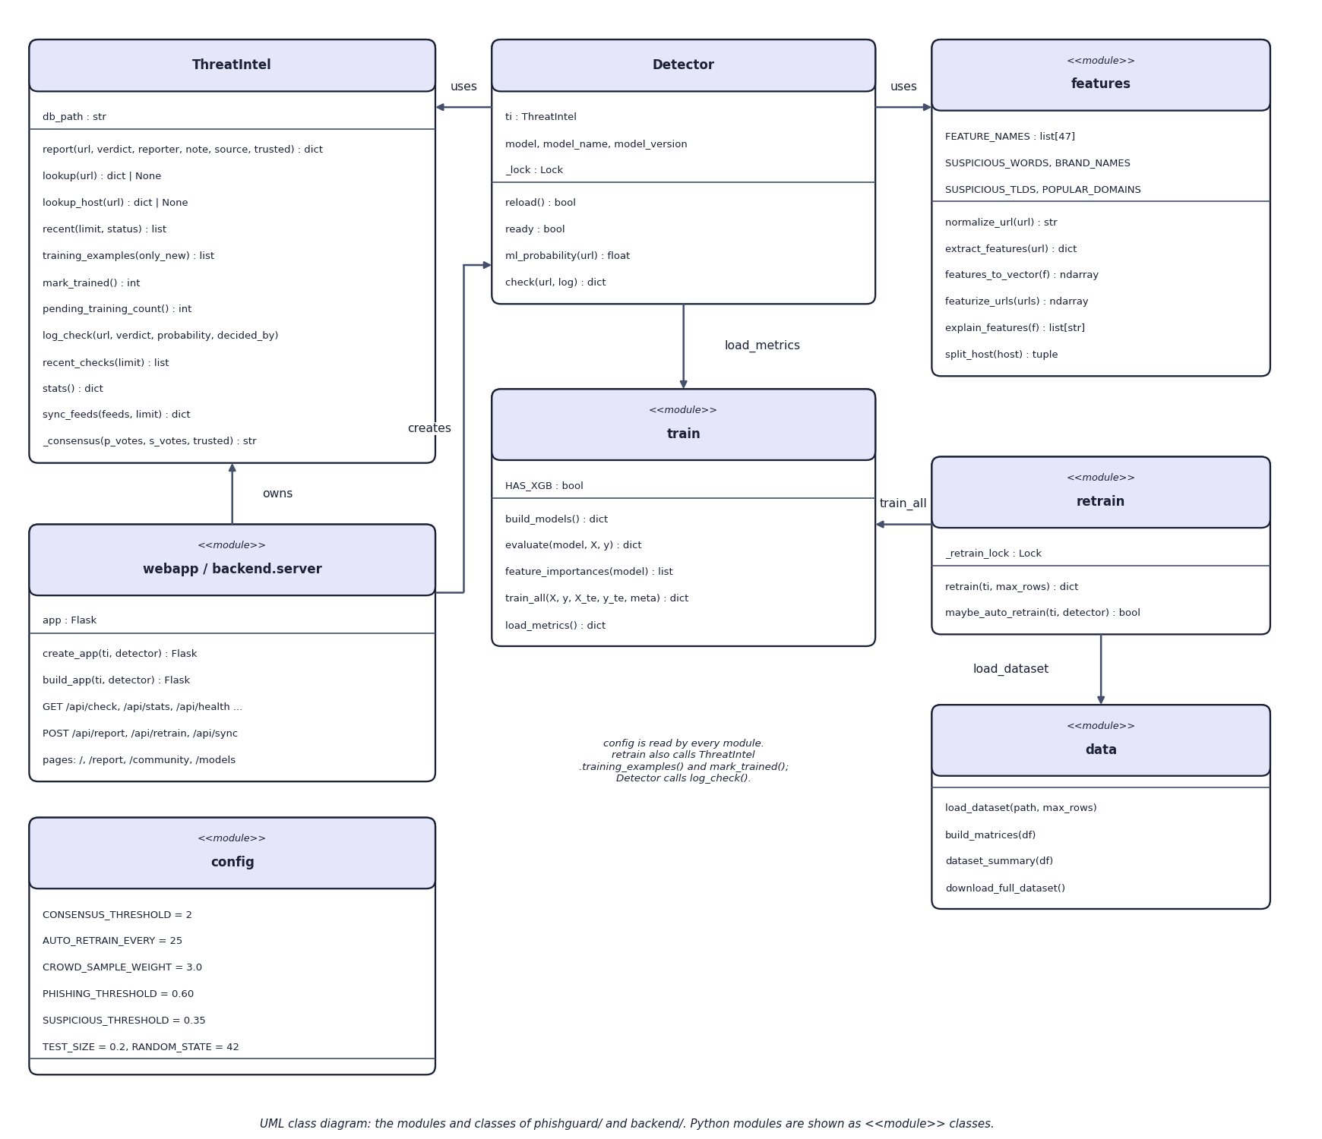
Fig. 2: UML class diagram of the Python modules
The class diagram shows the Python structure. ThreatIntel is the only real class with state (the database path). Detector holds a ThreatIntel, the loaded model, its name and version, and a lock that protects the model while it is swapped. features, train, retrain, data and config are modules of functions and constants, drawn as <<module>> classes. webapp and backend.server create the Flask application and call Detector.check. retrain calls train_all and load_dataset, and uses ThreatIntel's training_examples and mark_trained.

3 Database Design
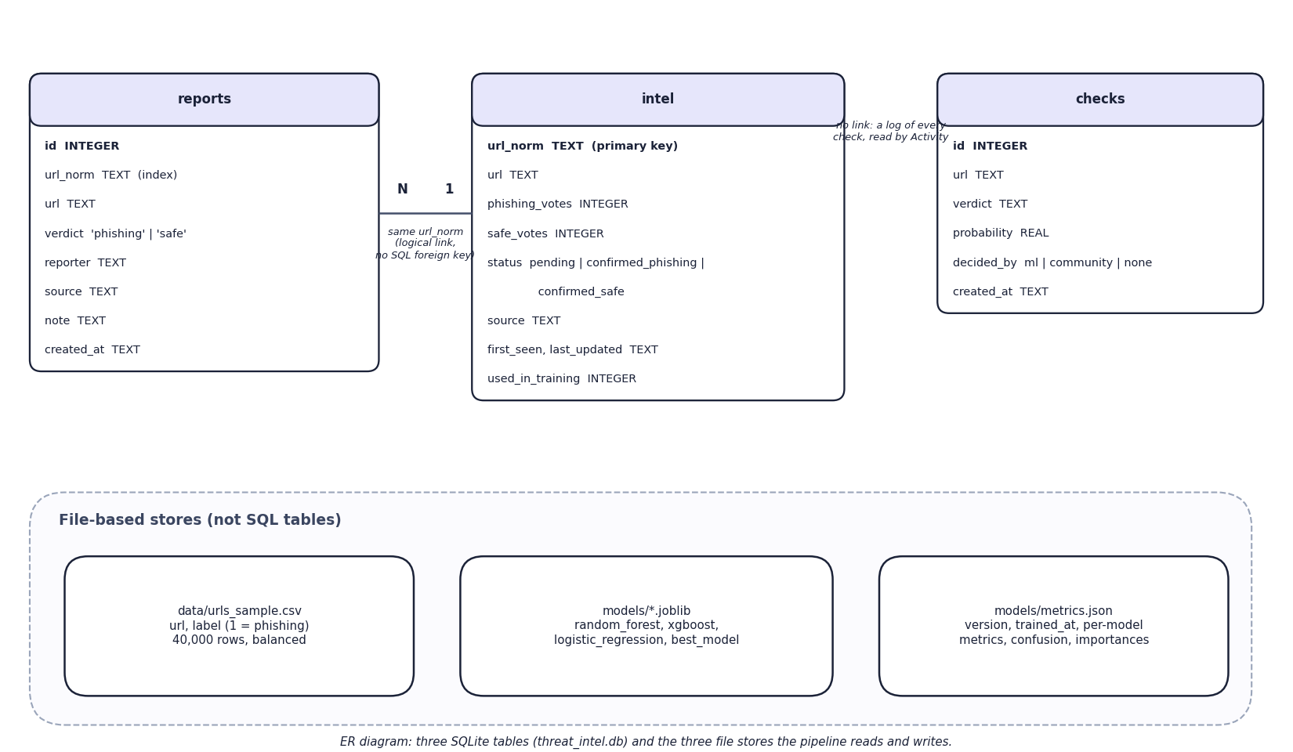
Fig. 3: Entity-relationship diagram
The database has three tables in threat_intel.db. reports stores every individual report (URL, verdict, reporter, source, note, time) and is indexed on the normalised URL. intel holds one row per normalised URL with its phishing and safe vote counts, its status (pending, confirmed_phishing or confirmed_safe), its source, first-seen and last-updated times and a flag showing whether it has been used in training. checks is an append-only log of every verdict. reports and intel are linked logically by the normalised URL; the schema declares no SQL foreign key. The lower panel shows the three file-based stores that the pipeline reads and writes.
Table 2: Schema of the SQLite database (phishguard/threat_intel.py)
Table | Column | Type | Notes
reports | id | INTEGER | primary key, autoincrement
 | url_norm, url | TEXT | normalised and original URL; index idx_reports_url on url_norm
 | verdict | TEXT | CHECK in ('phishing', 'safe')
 | reporter, source, note | TEXT | defaults: 'anonymous', 'community'
 | created_at | TEXT | UTC ISO time
intel | url_norm | TEXT | primary key
 | url | TEXT | first original form
 | phishing_votes, safe_votes | INTEGER | default 0
 | status | TEXT | pending | confirmed_phishing | confirmed_safe
 | source, first_seen, last_updated | TEXT | source is community or the feed name
 | used_in_training | INTEGER | 1 after a retrain has consumed the entry
checks | id, url, verdict, probability, decided_by, created_at | INTEGER, TEXT, REAL | append-only activity log

Each connection is opened per operation with a 30-second timeout and committed on exit, so the Flask worker threads and the background retrain thread do not share a connection. All statements use bound parameters.

4 Application Architecture
The application is a Flask app created by create_app(ti, detector). backend/server.py calls it unchanged, adds five read-only endpoints (/api/health, /api/config, /api/checks, /api/intel, /api/intel/lookup) and a CORS header, and serves on port 8103. The React frontend on port 5103 proxies /api and /retrain to it, so the browser makes only same-origin requests.
- Concurrency. Flask runs threaded. SQLite connections are opened per call. Model access is guarded by a lock, and a retrain lock makes a second concurrent retrain return "a retrain is already running".
- Hot reload. After a retrain, Detector.reload() loads best_model.joblib under the lock, so requests in flight use either the old or the new model, never a mix.
- Background retraining. The form route /retrain and automatic retraining start a daemon thread; /api/retrain is blocking. The interface polls /api/stats for the retraining flag every three seconds.
- State on disk. The community store, the model files and metrics.json are the only state; the application itself is stateless between requests.

5 API Design
Table 3: JSON API (port 8103)
Method | Path | Request | Response
GET | /api/check?url= | query url | verdict, probability, ml_probability, decided_by, reason, red_flags[], features{47}, model, model_version, community; 400 {error} for an empty URL
POST | /api/report | JSON url, verdict, reporter, note | the intel entry (votes, status, source, times); 400 for a bad verdict or URL
GET | /api/stats | - | threat_intel counters, metrics.json, retraining flag
POST | /api/retrain | - | blocking retrain; the new metrics summary
POST | /api/sync | - | per-feed result {ok, added} or {ok: false, error}
GET | /api/health | - | ok, model_ready, model, model_version
GET | /api/config | - | thresholds, consensus and retrain constants, feature names by group
GET | /api/checks?limit= | limit (1-500) | recent checks
GET | /api/intel?limit=&status= | optional filters | intel entries; 400 for an unknown status
GET | /api/intel/lookup?url= | query url | one entry with its last 10 reports; 400 for no URL

An example response of GET /api/check?url=http://secure-paypal-login.account-verify.tk/signin?user=a (abridged):
Listing: Abridged JSON response
{"verdict": "phishing", "probability": 0.9989, "decided_by": "ml", "model": "xgboost", "model_version": 1,
"reason": "Xgboost estimates a 99.9% phishing probability from 47 lexical, structural and domain features.",
"red_flags": ["Registered domain imitates a well-known brand but is not the official site", "..."],
"community": null, "features": {"url_length": 54, "suspicious_word_count": 4, "...": "..."}}

6 Key Code Walkthroughs

6.1 Consensus: when does a URL become confirmed
The status machine is a small pure function. Two net phishing votes, or a trusted feed, confirm phishing; two net safe votes confirm legitimate; anything else stays pending.
Listing: ThreatIntel._consensus
def _consensus(p_votes: int, s_votes: int, trusted: bool = False) -> str:
net = p_votes - s_votes
if trusted or net >= config.CONSENSUS_THRESHOLD:
return "confirmed_phishing"
if -net >= config.CONSENSUS_THRESHOLD:
return "confirmed_safe"
return "pending"

6.2 Retraining: weighting and hot reload
Confirmed URLs replace any base-data rows they re-label, are repeated three times, and are split with the same stratified seed.
Listing: retrain.retrain (excerpt)
crowd = ti.training_examples()
crowd_df = pd.DataFrame(crowd, columns=["url", "label"]).astype({"url": str, "label": int})
if verbose:
print(f"Base dataset: {len(base)} rows | crowdsourced confirmed: {len(crowd_df)} rows")

# remove base rows that the crowd has since re-labelled
if len(crowd_df):
base = base[~base["url"].isin(crowd_df["url"])]
full = pd.concat([base, crowd_df], ignore_index=True)
weights = np.concatenate([
np.ones(len(base)), np.full(len(crowd_df), config.CROWD_SAMPLE_WEIGHT)])

X = featurize_urls(full["url"].tolist())
y = full["label"].astype(int).to_numpy()
X_tr, X_te, y_tr, y_te, w_tr, _ = train_test_split(
X, y, weights, test_size=config.TEST_SIZE,
random_state=config.RANDOM_STATE, stratify=y)

# sample weights are passed by duplicating weighted rows (works for every model)
reps = np.round(w_tr).astype(int)
X_tr = np.repeat(X_tr, reps, axis=0)
y_tr = np.repeat(y_tr, reps, axis=0)

6.3 Decision order in the detector
The decision order is the heart of the system: community first, then the model, then adjustments and thresholds (see the flowchart in Chapter 5).
Listing: Detector.check (excerpt)
# 1. crowdsourced intelligence
intel = self.ti.lookup(url_norm) or self.ti.lookup_host(url_norm)
ml_prob = self.ml_probability(url_norm) if self.ready else None
result["ml_probability"] = None if ml_prob is None else round(ml_prob, 4)
result["community"] = None
if intel:
result["community"] = {
"status": intel["status"],
"phishing_votes": intel["phishing_votes"],
"safe_votes": intel["safe_votes"],
"source": intel["source"],
"last_updated": intel["last_updated"],
}
if intel and intel["status"] == "confirmed_phishing":
result.update(verdict="phishing", probability=max(0.97, ml_prob or 0),
decided_by="community", reason=(
f"Confirmed phishing by crowdsourced threat intelligence "
f"({intel['phishing_votes']} phishing vs {intel['safe_votes']} safe "
f"reports, source: {intel['source']})."))
elif intel and intel["status"] == "confirmed_safe":
result.update(verdict="safe", probability=min(0.03, ml_prob or 0),
decided_by="community",
reason="Confirmed legitimate by community consensus.")
elif ml_prob is None:
result.update(verdict="unknown", probability=None, decided_by="none",
reason="No trained model found - run `python run.py train` first.")
else:
# 2./3. ML with soft community evidence
prob = ml_prob
reputable = feats["is_popular_domain"] and (feats["is_common_tld"] or feats["tld_length"] > 2)
if reputable: # domain-reputation adjustment for well-known registered domains
prob *= 0.4
if intel:
net = intel["phishing_votes"] - intel["safe_votes"]
prob = float(np.clip(prob + 0.15 * net, 0.0, 1.0))
if prob >= config.PHISHING_THRESHOLD:
verdict = "phishing"
elif prob >= config.SUSPICIOUS_THRESHOLD:

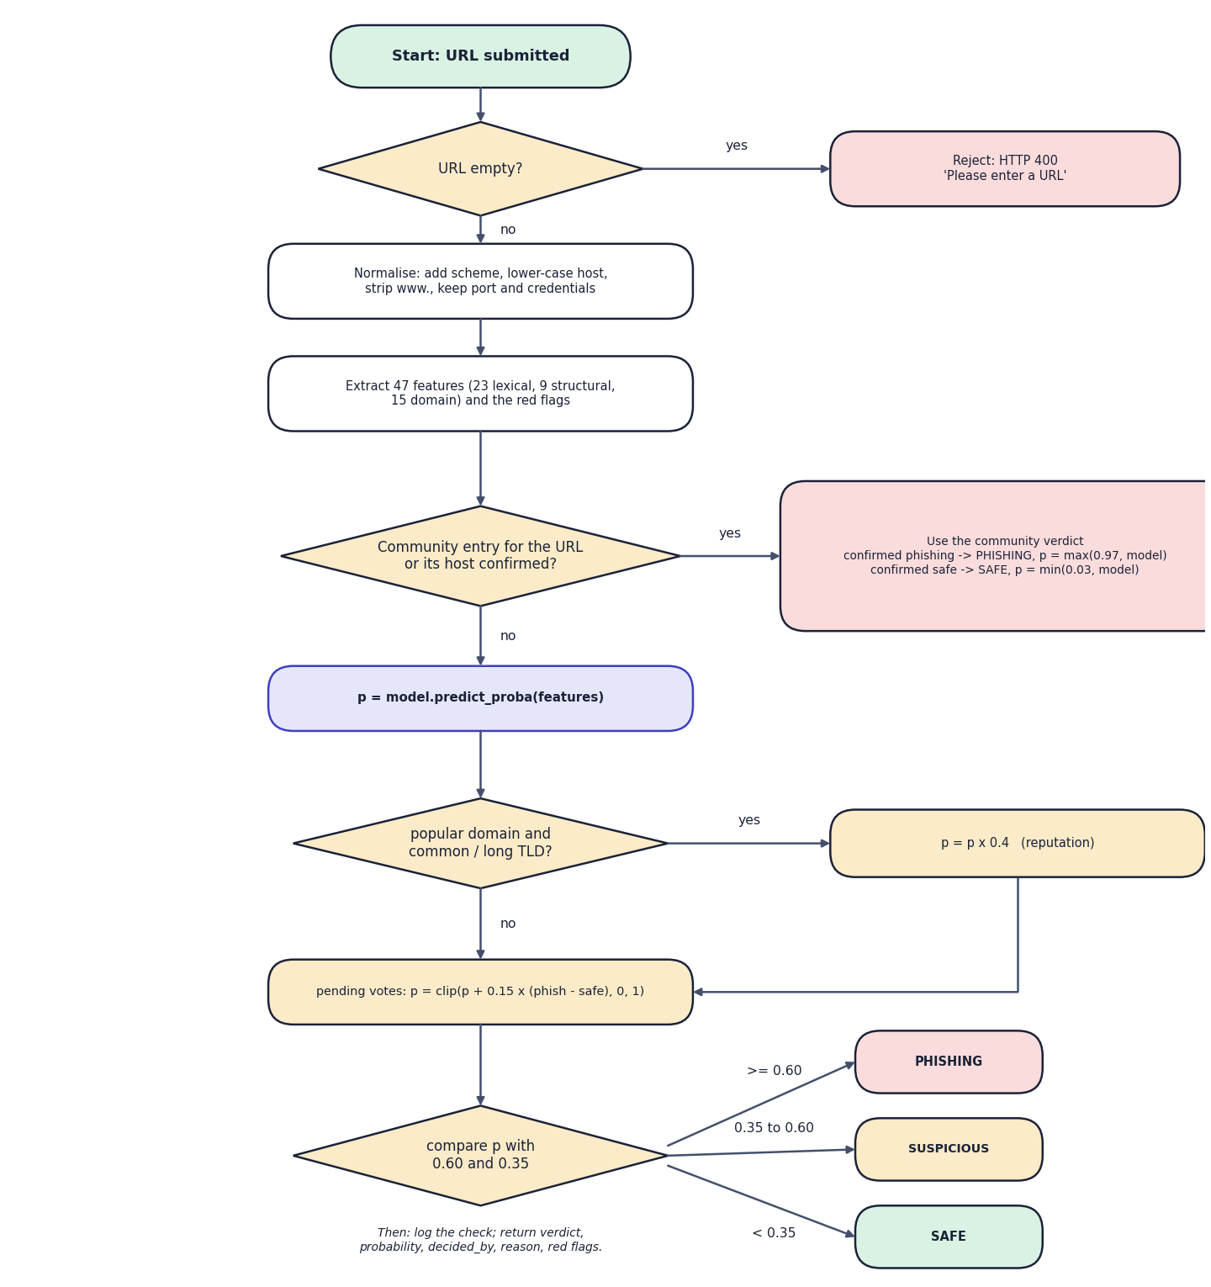
Fig. 4: Flowchart of the core algorithm (decision order of detector.check)
The flowchart is the decision procedure of Detector.check. An empty URL is rejected with HTTP 400. Otherwise the URL is normalised, 47 features and the red flags are extracted, and the community store is queried for the URL and for its host. A confirmed community entry decides at once: confirmed phishing gives probability max(0.97, model) and confirmed safe gives min(0.03, model). Otherwise the model produces p; a well-known registered domain multiplies p by 0.4; pending votes add 0.15 per net vote; and p is compared with 0.60 (phishing) and 0.35 (suspicious). Every outcome is logged and returned with its reason.

7 Implementation Decisions and Reasoning
Table 4: Main implementation decisions
Decision | Reasoning | Consequence
Offline URL-only features | Training and run time must use identical code; fetching pages is slow and risky | Fast and safe; cannot see page content
Three classical models, not a deep network | Objective 3 names them; they train in seconds and give importances | Lower accuracy than the base paper's network
Same split and features for every model | A fair comparison needs identical data | Differences reflect the algorithm only
Select by F1, break ties by ROC-AUC | Classes are balanced; F1 balances missed phishing and false alarms | XGBoost selected
Community verdict before the model | A confirmed human verdict is stronger evidence than a score; it gives zero-day coverage at once | Wrong consensus overrides a right model
Net votes of 2 for confirmation | Simple, explainable, quick; one report is not enough | Two cooperating reporters can confirm anything
Confirmed-safe status | The community must be able to undo false positives (problem statement point 4) | Not in the base paper
Host-level lookup | A confirmed phishing host usually serves many pages | Over-blocks shared hosts
Reputation discount x0.4 for popular domains | Cuts false alarms on well-known sites cheaply | Hand-written list; misses amazon.in and docs.python.org
Retrain weight 3 by row repetition | Works with every model without special sample-weight support | Memory grows with weight
Hot reload under a lock | Avoid restarts and torn reads of the model | In-flight requests use old or new model, never a mix
Keep the original Flask app and add an API layer | Preserves the tested pages and CLI; the new UI needs only a thin, additive layer | Two interfaces to maintain
SQLite | Single file, no server, enough for a local deployment | Not for heavy concurrent writes

8 Security and Error Handling
- The URL is never fetched. The system only reads the string, so a malicious URL cannot execute anything or make the server contact it.
- Parameterised SQL. Every statement binds its values; a SQL-injection string in a URL or reporter name is stored as plain data (tested).
- Output escaping. The Flask pages use Jinja auto-escaping and React escapes by default; script tags in reported URLs, notes and names are not executed (tested).
- Input validation. An empty or whitespace-only URL, an unknown verdict and an unknown status each return HTTP 400 with a JSON error.
- Bounded work. Batch checks are limited to 100 URLs in the interface; feed synchronisation adds at most 500 URLs per feed and has a 20-second timeout.
- Failure isolation. A failing feed is reported per feed and never stops the application; the interface shows a clear message if the backend is unreachable.
- Secrets. The application needs none. The .env file holds only ports (and an unrelated API key that PhishGuard does not read).
- Known weaknesses. No authentication, CORS *, anonymous reports, no rate limit, and feed URLs accepted without verification. These are listed as limitations.

9 User Interface Design
The interface is a React single-page application with a landing page and a six-item side navigation (Check URL, Report, Threat intelligence, Models, Activity, Landing page). Colour carries meaning consistently: red for phishing, amber for suspicious, green for safe. Every result shows a probability gauge and a risk scale with the two thresholds marked, so the user sees how close a verdict is to the boundary. A light and a dark theme are available.
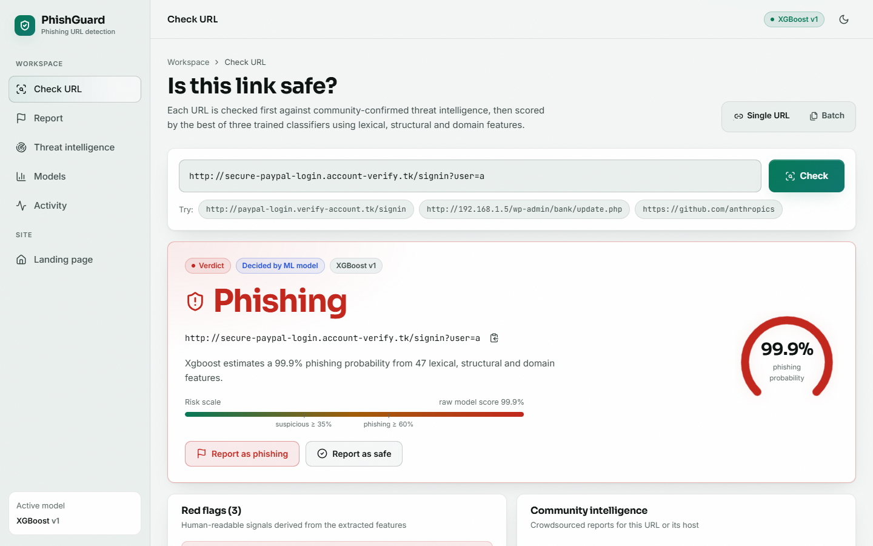
Fig. 5: Check URL screen: verdict, probability gauge and risk scale

Fig. 6: Models screen: comparison, confusion matrix and feature importances
- Check URL. Single and batch tabs; example URLs; verdict card; red flags; community status; the 47 extracted features; recent checks.
- Report. URL, phishing or safe, reporter name and note, with the consensus rule explained beside the form.
- Threat intelligence. Counters, a searchable table with status and vote columns, a detail drawer and a feed-sync dialog.
- Models. Metric cards, bar and radar charts, comparison table, confusion matrix, top-10 feature importances and the retrain control.
- Activity. Check log with a probability trend, verdict mix and search.
- States. Loading skeletons, empty states and a clear message when the backend is unreachable.

10 Installation and Execution
Windows, one command. From 8.ProjectCode, run.bat trains the models if models/best_model.joblib is missing, installs the frontend dependencies on first run, opens the API (port 8103) and the interface (port 5103) in two windows and launches the browser.
Listing: Manual start
pip install -r requirements.txt
python run.py train # under a minute: features + three models
python backend/server.py # API on http://127.0.0.1:8103
cd frontend && npm install && npm run dev # UI on http://localhost:5103

Table 5: Command-line interface
Command | Purpose
python run.py train | Train and compare the three models; write models/ and metrics.json
python run.py check <url> | Classify from the terminal
python run.py report <url> phishing|safe --reporter NAME | File a community report
python run.py sync | Import OpenPhish and URLhaus URLs (needs internet)
python run.py retrain | Retrain with confirmed URLs
python run.py serve | Original Flask interface on port 5000
python run.py download | Fetch the full dataset (not used in this report)
python tests.py; python scripts/smoke_test.py; python scripts/extra_tests.py | Run the automated checks

